Matrix7. Unit1. Nouns
Ex.1. Fill in the missing letters, spell and translate
ac_om_oda_ion, t_ins, _d_lt, s_g_es_ion, a_tit_de, s_ _ret, _elebrit_, scr_am, c_nfe_sion, p_y_hologist, con_act, pr_sente_, d_sas_er, o_der, e_plan_tion, o_fer, h_bit, m_ster_.
Ex.2. Guess the word
1. the details or other information that someone gives to make something clear or easy to understand, 2. someone who is no longer a child and is legally responsible for their actions, 3.the way you feel about something or someone, or a particular feeling or opinion, 4. two children born to the same mother on the same occasion
5. a place to live or stay, 6. someone who is famous, esp. in the entertainment business, 7. someone who studies the mind and emotions and their relationship to behavior., 8. a statement about yourself that you would not normally make because you are embarrassed about it or because people could be disappointed by it, 9. a particular act or way of acting that you tend to do regularly, 10. something strange or unknown which has not yet been explained or understood, 11. a loud high sound you make when you are frightened, excited, or angry, 12. an idea, possible plan, or action that is mentioned for other people to consider , 13. an event causing great harm, damage or suffering, 14. someone who introduces a television or radio show .
Ex.3. Fill in the gaps with the appropriate words from the table.
accommodation | adult | attitude | confession | Disaster
explanation | habit | mystery
presenter | psychologist | scream | suggestion | twins
7. Eating between meals is a bad _________.
2.Tickets are £2.50 for __________ and £1.50 for children.
4. He made a ___________ that he had loved her.
3.Start each day with a positive __________.
1. The price includes travel and _____________ but meals are extra.
5. The expedition ended in __________, with three people being hurt.
6. This book provides a clear ____________ of how to use the Internet.
11. I heard a _________ of laughter from the next room.
8. The reasons of his sudden death remain a ___________.
10. If you have some problems, you can visit a _____________ and ask for some help.
12. Bob and Mike are _________, They are so similar!
9. Mike Brown is a new ______________ of that TV show.
Matrix7. Unit1. Verbs. Adjectives.
Ex.4. These letters are mixed. Make up the words from them.
1. cpecat-________ 2. tsegusg-__________ 3.masecr________ 4. iel________
5.repapa-_______ 6.name_________ 7. eramopc_______ 8. cedide______
9. aled_________ 10. tepxec__________ 11.fele_________ 12. movepir__________
Ex.5. Find the verbs from ex. 3 in this puzzle.
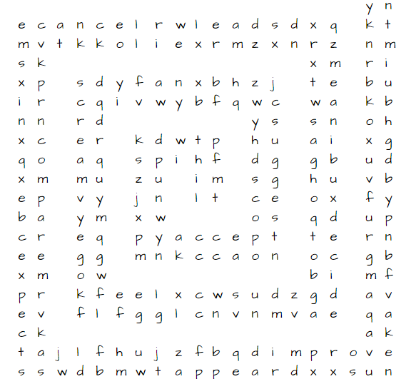
Ex.6. Write down three forms of these verbs(In copybooks!!!)
1. Accept, appear, cancel, compare, decide, expect, improve, lie, scream, suggest.
2. Feel, mean, lead.
Ex.7. Put the adjectives into two groups-positive and negative. (In copybooks!!!)
active, alive, available, cheerful, cultural, dishonest, elderly, excellent, fit, generous, healthy, honest, impatient, insensitive, lazy, lively, mean, miserable, optimistic, outgoing, patient, pessimistic, polite, rude, sensible, sensitive, shy, silly.

