Демонстрационный вариант
вступительного теста по английскому языку для 7 класса
2 триместр
Вариант 1
Часть1
1. Fill the gaps with the corrects forms of the verbs in Present Simple.
- I ________ (to like) bananas.
- Ann ________ (not to play) football every weekend.
- We ________ (to go) to work by tram.
- You ________ (not to work) very hard.
- My friend and I ________ (to spend) time together at the weekend.
2. Fill the gaps with do/does.
- What colour ________ you like?
- Where ________ she live?
- Where ________ your parents work?
- What kind of films ________ he prefer?
- ________ he play football at the weekends?
3. Complete the text with the correct object pronouns.
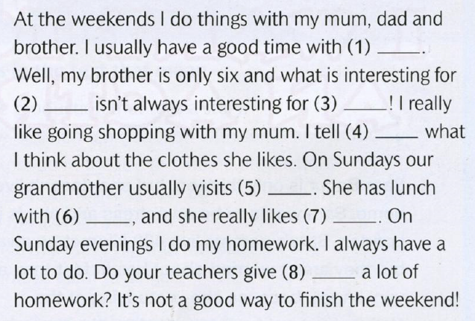
4. Use the verbs in an appropriate tense Present Continuous or Present Simple.
1.I_____________ (to read) books in the morning.
2. He_____________ (not to help) his mother at the weekend.
3. I _____________ (to write) an exercise now.
4. I _____________ (not to write) a letter now.
5. They_____________ (to play) in the yard now.
6. You_____________ (not to play) in the street now.
7. Look! The baby ______________(to cry).
8. He _____________ (to help) his parents every day.
9. He _____________ (to visit) his grandparents in summer?
10. I __________(not to read) books in the evening.

5. Fill the gaps with the correct form of the adjectives.
- The Volga is………………(long) river in Europe.
- Life in the country is………………(relaxing) than in the city.
- She is one of………………(rich) people in the world.
- My house is………………(expensive) than yours.
- The weather today is…………………(good) than it was yesterday.
6. Fill the gaps with some/any.
- Is there ______ juice on the table? – Yes, there is ______ juice on the table.
- Give me ______ butter please. – But there isn’t ______ butter in the fridge.
- Are there ______ shopping malls in the center of the city? – Yes, there are ______ shopping malls in the center of the city.

7. Fill the gaps with much/many.
- How ___________ children are there in your class?
- How ___________ milk do you want in your tea?
- How ___________ bread do you eat every day?
- How ___________ players are there in a football team?

8. Fill the gaps with the correct form of the verbs (Past Simple/Past Continuous)
1. It ______________________ (rain) when they __________________ (come) out of the shopping centre.
2. I ______________________ (be) ill two weeks ago.
3. She ______________________ (break)his leg when she ______________________ (ski) .
4. He ______________________ (read) a book when his father _________________(come) home.
5. Emma ______________________ (pass) her exam last week.
6. When they ______________________ (see) the spaceship they ___________________(stop) the car.
7. When ______________________ (you buy) a new table? – I ______________________ (buy) it a few years ago.
8. He ______________________ (sit) in the garden when he ______________________(see) a rainbow in the sky.
9. Claire ______________________ (go) to Turkey last month.
10. She ______________________ (have) a beautiful dream when the alarm clock ________________ (ring).
9. Use the verbs in brackets in the correct future tenses. Use will, going to, Simple Present or Present Continuous.

1) The bus ______________at 11:55.(to leave)
2) We ______________dinner tomorrow at six o'clock.(to have)
3) Look at the clouds! It____________________. (to rain)
4) On Sunday at 8 o'clock I______________ my friend. (to meet)
5) They ______________to London on Friday evening. (to fly)
6) Wait! I ______________you to the station. (to drive)
7) The English lesson ____________at 8:45. (to start)

8) Listen! There's someone at the door. I ______________the door for you. (to open)

10. Put the verbs in brackets in the Past Simple or in the Present Perfect.
1. I ________ (never/ be) to France. I ______ (want) to go there last summer but I couldn’t.
2. He _______ (live) in London all his life.
3. His father ________ (come back) to London last Sunday.
4. Yan __________ (write) a letter to Nick two days ago.
5. He ________ (send) his letter yesterday.
6. They ________ (just/ buy) some postcards.
11. First Conditional. Put the verbs in the brackets into the Present Simple or the Future Simple Tense(will) .
- If Mary __________ (come) to my place, we__________ (watch) an interesting film.
- If Peter__________ (not come) to my place, I __________ (watch) TV.
- If Frank’s parents__________ (have) their holidays in summer, they __________ (go) to the seaside.
- In case they __________ (have) their holidays in winter, they __________ (stay) at home.
- If the fog _______ (not to thicken), Harold _______ (not to stay) outside.

12. Rewrite the sentences and use the second
conditional.
have a job/ earn some money
If I had a job, I would earn some money.
1. have some money/ go to the cinema
_________________________________________________________
2.go to the cinema/ see a horror film
_____________________________________________________________
3, see a horror film/ be scared
___________________________________________________________
4. be scared/ close my eyes
___________________________________________________________
5.close my eyes/ fall asleep
__________________________________________________________________
6. fall asleep/ miss the end of the film
____________________________________________________________________

13. Underline the correct answers.
A.
1. I listen to a lot of / a few music on my MP3 player.
2. I've got a little/ a few new CDs too.
3.Would you like to listen to some/ much CDs now?
B.
4.- Are you thirsty? Here's many/ some orange juice. How much do you want?
5. -I only want a few/ a little, thanks.

Часть 2
Устно ответьте на данные вопросы.
1. Is your family big or small?
2. Have you got a pet?
3. Do you have any hobbies? What do you do in your free time?
4.Do you have many friends? What qualities do you think make a good friend?
5. Do you like to watch plays? Do you perform in plays?
6. Who is your favourite actor/actress? Tell me about him/her.
7. How many hours of TV do you watch every day? Which TV programmes do you prefer? Which TV programmes do you hate?
8. What is a hero? What qualities do you think make a hero?
9. Can you remember a situation when you were anxious of afraid? What happened? When did it happen? Who were you with? What happened in the end?
10. What type of holiday do you like? Where did you go last year?
11. What is the most interesting place you've ever visited?
12. Which subjects do you get the most homework for? When do you do your homework?
13. How much spare time do you have in the evening?

14. What do you want to be when you're older?
15. How often do you use a computer/ a mobile phone?
What do you use it for?

Ответы к заданиям.
1.  1-like  2-doesn't like  3-go  4-don't work  5-spend  2.  1-do  2-does  3-do  4-does  5-does  3.  1-them  2-him  3-me  4-her  5-us  6-us  7-us  8-you  4.  1-read  2-does help  3-am writing  4-am not writing  5-are playing  6-are not playing  7-is crying  8-doesn't help  9-does he visit  10-don't read  5.  1-the longest  2-more relaxing  3-the richest  4-more expensive  5-better  6.  1-any/some  2-some/any  3-any/some  7.  1-many  2-much  3-much  4-many | 8.  1-was raining/came  2-was  3-broke/skiing  4-was reading/came  5-passed  6-saw/stopped  7-did you buy/bought  8-was sitting/saw  9-went  10-was having/rang  9.  1-leaves  2-are having  3-is going  4-is going  5-are flying  6-will drive  7-starts  8-will open  10.  1-have never been/wanted  2-has lived  3-came back  4-wrote  5-sent  6-have just bought  11.  1-comes/will watch  2-doesn't come/will watch  3-have/will go  4-have/will stay  5-doesn't thicken/will not stay  12. 1. If I had ..., I would go...  2. If I went...,I would see...  3. If I saw, I would be...  4. If I were, I would close...  5. If I closed.., I would fall...  6. If I fell.., I would miss...  13.  1. a lot of  2. a few  3. some  4.some  5. a little

